Geometric Primitive Services
Chapter
3

2D Geometric Primitives
The 2 Dimensional Geometric Primitives Package provides point, rectangle, size, vector, line, and line segment geometric constructs. The classes in this package are typically used as helpers when dealing with geometrical constructs. The primitives in this package reflect geometric constructs in real coordinate space.

Logical Design

Static Models

Dynamic Models
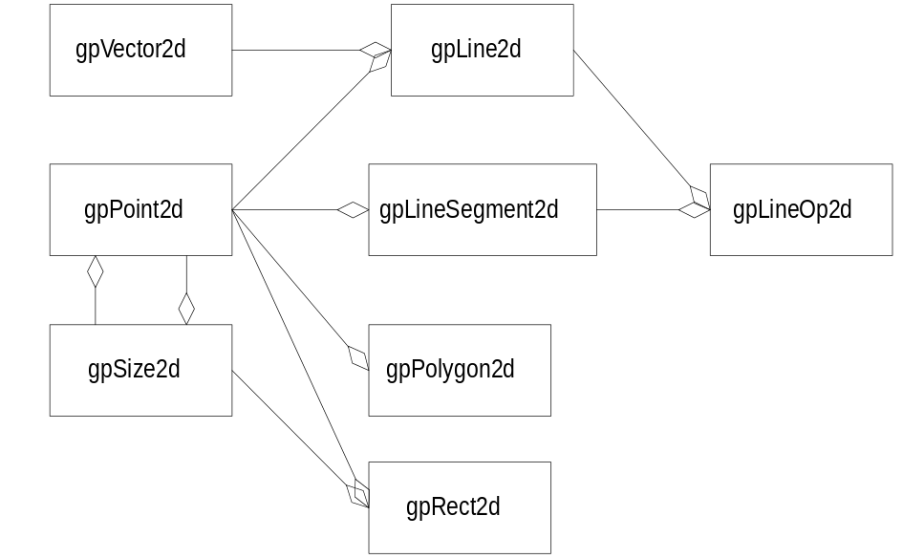
Martin Metrics
N | 6
R | 8
H | 1.5
C_{a} | -
C_{e} | 0
I | 0
A | 0
D | 0.707
D’ | 1

Physical Design
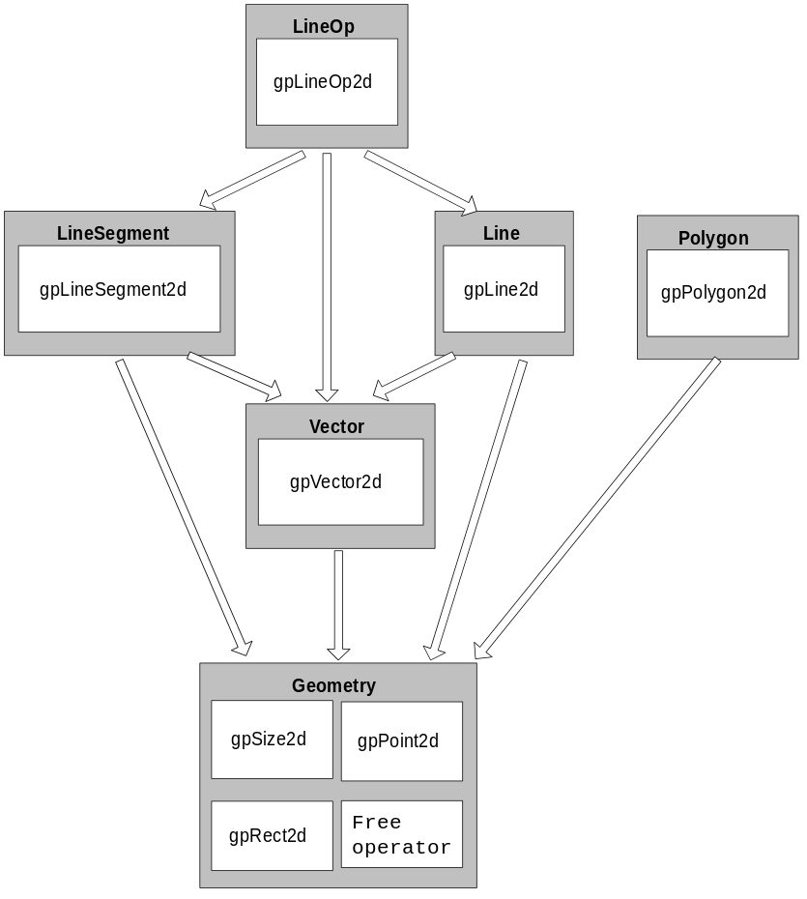
Component | Level | Number of components that must be developed in order to test this component.
Geometry | 1 | 1
Line | 3 | 3
LineSegment | 3 | 3
Vector | 2 | 2
Polygon | 2 | 2
LineOp | 4 | 5
N |  | 4
CCD |  | 9
ACD |  | 2.25
CCD_{Balanced Binary Tree} |  | 7.61
NCCD |  | 1.18

Specifications

gpSize2d
gpSize2d encapsulates the notion of a two-dimensional quantity that usually represents a displacement or the height and width of a rectangle.

Public Interface - Member Functions
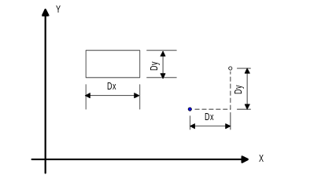
gpSize2d
gpSize2d();
Default constructor. Sets the dimensions to zero.
gpSize2d
gpSize2d(Float64 dx, Float64 dy);
Explicit constructor. Creates a gpSize2d object with dimensions dx by dy.
gpSize2d
gpSize2d(const gpPoint2d& point);
Explicit constructor. Creates a gpSize2d object with dimensions point.X() by point.Y().
gpSize2d
gpSize2d(const gpSize2d& size);
Copy constructor. Creates a gpSize2d with Dx = size.Dx() and Dy = size.Dy().
operator =
gpSize2d& operator = (const gpSize2d& rOther);
Assignment operator. Assigns rOther.Dx() to Dx and rOther.Dy() to Dy. Returns a reference to this size object.
operator +
gpSize2d operator + (const gpSize2d& size) const;
Calculates an offset to this gpSize2d object using the given size argument as the displacement. Returns the object (dx+size.Dx(),dy+size.Dy()). This object is not changed.
operator -
gpSize2d operator - (const gpSize2d& size) const;
Calculates a negative offset to this gpSize2d object using the given size argument as the displacement. Returns the object (dx-size.Dx(),dy-size.Dy()). This object is not changed.
operator - ()
gpSize2d operator - () const;
Returns the gpSize2d object (-Dx, -Dy). This object is not changed.
operator ==
bool oprator == (const gpSize2d& rOther) const;
Returns true if this gpSize2d object is equal to the rOther gpSize2d object, otherwise returns false.
operator !=
bool operator != (const gpSize2d& rOther) const;
Returns false if this gpSize2d object is equal to the rOther gpSize2d object, otherwise returns true.
operator +
gpSize2d& operator + (const gpSize2d& size);
Offsets this gpSize2d object by the given size argument. This gpSize2d object is changed to (Dx + size.Dx(),Dy+size.Dy()). Returns a reference to this object.
operator -=
gpSize2d& operator -= (const gpSize2d& size);
Negatively offsets this gpSize2d object by the given size arguement. This gpSize2d object is changed to (Dx-size.Dx(),Dy-size.Dy()). Returns a reference to this object.
Magnitude
Float64 Magnitude() const;
Returns the length of the diagonal of the rectangle represented by this object.
Dx
Float64 Dx() const
Float64& Dx();
Returns the size in the x direction.
Dy
Float64 Dy() const
Float64& Dy();
Returns the size in the y direction.

Implementation Notes
If we find ourselves frequently comparing the Magnitude of size objects, it is faster to compare the relative magnitude. Relative magnitude is the square of the magnitude. The square root operation is quite expensive to use. Below is a specification for RelMagnitude.
RelMagnitude
Float64 RelMagnitude() const;
Returns the relative length of the diagonal of the rectangle represented by this object. The relative length is the square of the length of the diagonal. It is more efficient to use this method when an exact measure isn’t necessarily needed because the costly square root operation is not performed.

gpPoint2d
gpPoint2d encapsulates the notion of a two-dimensional point that represents a position in a Cartesian coordinate system.

Public Interface - Member Functions
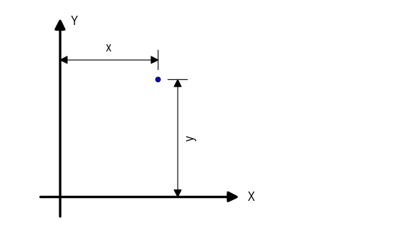
gpPoint2d
gpPoint2d();
Default constructor. Sets X and Y coordinates to zero.
gpPoint2d
gpPoint2d(Float64 x, Float64 y);
Explicit constructor. Initializes X and Y coordinates with x and y, respectively.
gpPoint2d
gpPoint2d(const gpPoint2d& rOther);
Copy constructor. Initializes X and Y coordinates with rOther.X() and rOther.Y(), respectively.
operator =
gpPoint2d& operator = (const gpPoint2d& p);
Assignment operator
operator +
gpPoint2d operator + (const gpSize2d& size) const;
Calculates an offset to this point using the given size arguemnt as the displacement. Returns (x + size.Dx(), y + size.Dy()). This point is not changed.
operator -
gpPoint2d operator - (const gpSize2d& size) const;
Calculates an offset to this point using the given size arguemnt as the displacement. Returns (x - size.Dx(), y - size.Dy()). This point is not changed.
operator -
gpPoint2d operator - () const;
Returns the point (-x,-y). This point is not changed.
operator +=
gpPoint2d& operator += (const gpSize2d &size);
Offsets this point by the given size argument. This point is changed to (x + size.Dx(),y + size.Dy()). Returns a reference to this point.
operator -=
gpPoint2d& operator -= (const gpSize2d &size);
Negatively offsets this point by the given size argument. This point is changed to (x + size.Dx(),y + size.Dy()). Returns a reference to this point.
Magnitude
Float64 Magnitude() const;
Returns the distance between the origin and the point
Move
void Move(const gpPoint2d& newPosition);
void Move(Float64 x, Float64 y);
Moves the point to a new position
Distance
Float64 Distance(const gpPoint2d& p) const;
Returns the distance from this point and point p.
Offset
gpPoint2d& Offset(Float64 dx,Float64 dy);
gpPoint2d& Offset(const gpSize2d& size);
Offsets this point by the given delta arguments. This point is changed to (x+dx,y+dy) or (x + size.Dx(), y + size.Dy()). Returns a reference to this point.
OffsetBy
gpPoint2d OffsetBy(Float64 dx, Float64 dy) const;
gpPoint2d OffsetBy(const gpSize2d& size) const;
Calculates an offset to this point using the given displacement arguments. Returns the point (x+dx,y+dy) or (x+size.Dx(),y+size.Dy()). This point is not changed.
Rotate
gpPoint2d& Rotate(const gpPoint2d& centerPoint, Float64 angle);
Rotates this point about the given center point by the given angle (in radians). This point is changed. Returns a reference to this point.
RotateBy
gpPoint2d RotateBy(const gpPoint2d& centerPoint, Float64 angle) const;
Returns a point equal to this point rotated about the given center point by the given angle (in radians). This point is not changed.
X
Float64 X() const;
Float64& X();
Returns the x coordinate of the point.
Y
Float64 Y() const;
Float64& Y();
Returns the y coordinate of the point

Free Operators
operator ==
bool operator==(const gpPoint2d& lhs, const gpPoint2d& rhs);
Returns true if lhs is equal to rhs, otherwise returns false.
operator !=
bool operator!=(const gpPoint2d& lhs, const gpPoint2d& rhs);
Returns true if lhs is not equal to rhs, otherwise returns false.

Implementation Notes
We have chosen to return the X and Y coordinates by reference, using the attributes as objects design. There are many down sides to treating attributes as objects but this is such a lightweight class, they really don’t come into play. The only real disadvantage is that the interface gives clients of this class a hint as to how X and Y are stored. The reality is, it is very unlikely X and Y would be stored any differently.
If we find ourselves frequently comparing the Magnitude of points, it is faster to compare the relative magnitude. Relative magnitude is the square of the distance from the origin to the point. The square root operation is quite expensive to use. Below is a specification for RelMagnitude.
RelMagnitude
Float64 RelMagnitude() const;
Returns the relative distance between the origin and the point The relative distance is the square of the distance between the origin and the point. It is more efficient to use this method when an exact distance from the origin isn’t necessarily needed because the costly square root operation is not performed.

gpVector2d
gpVector2d encapsulates the notion of a two-dimensional vector. A vector has a magnitude and a direction. Cartisian components of a vector may be represented by a gpSize2d object.

Public Interface - Member Functions
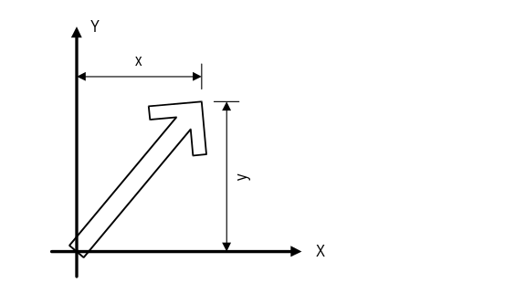
gpVector2d
gpVector2d();
Default constructor. Creates a zero vector.
gpVector2d
gpVector2d(Float64 x, Float64 y);
Explicit constructor. Creates a vector that goes from the origin to the point (x,y).
gpVector2d
gpVector2d(Float64 magnitude, Float64 angle);
Explicit constructor. Creates a vector of a given magnitude and direction angle. The direction angle is measured in radians counterclockwise from the x axis.
gpVector2d
gpVector2d(const gpSize2d& size);
Explicit constructor. Creates a vector that has x and y components equal to size.Dx() and size.Dy().
gpVector2d
gpVector2d(const gpVector2d& rOther);
Copy constructor.
operator =
gpVector2d& operator = (const gpVector2d& rOther);
Assignment operator
operator -
gpVector2d operator - () const;
Returns the vector (-x,-y). This is not changed.
operator +=
gpVector2d& operator += (const gpVector2d &vector);
Adds this vector by the given vector argument. This is changed to (x + vector.X(),y + vector.Y()). Returns a reference to this vector.
operator -=
gpVector2d& operator -= (const gpVector2d &vector);
Subtracts the given vector from this. This is changed to (x - vector.X(),y + vector.Y()). Returns a reference to this vector.
AngleBetween
Float64 AngleBetween(const gpVector2d& rOther) const;
Returns the angle from this vector towards rOther.
Projection
Float64 Projection(const gpVector2d& rOther) const;
Returns the component of this vector along rOther. Equivalent to this->Dot(rOther)/rother.Magnitude()
Dot
Float64 Dot(const gpVector2d& rOther) const;
Dot Product. Returns the dot product with this and rOther.
GetDirection
Float64 GetDirection() const;
Get direction angle in radians. The angle is measure counterclockwise from the positive X direction.
GetSize
gpSize2d SetSize()const;
Returns a gpSize2d object that has Dx and Dy equal to the x and y components of this vector.
IsZero
bool IsZero() const;
Returns true if this vector is the zero vector.
IsCollinear
bool IsCollinear(const gpVector2d& rOther) const;
Returns true if this vector is collinear with rOther.
GetMagnitude
Float64 GetMagnitude() const;
Returns the magnitude of the vector.
GetRelMagnitude
Float64 GetRelMagnitude() const;
Returns the magnitude of the vector squared. This method is faster than Magnitude() when only comparing..
Reflect
gpVector2d& Reflect();
Reflection or negation. Changes this to the vector (-x,-y) and returns a reference to it.
Normalize
gpVector2d& Normalize();
Normalizes (i.e., makes a unit vector) this vector and returns a reference to it. Changes this vector.
NormalizeBy
gpVector2d NormalizeBy() const;
Normalizes (i.e., makes a unit vector) this vector and returns a copy of it. This vector is not changed.
Normal
gpVector2d Normal(gpVector2d::Side side=Left) const;
Returns a vector perpendicular to this and of the same length. The new vector is basically this vector rotated 90 either to the left or right. This function is much faster and more accurate than calling RotateBy(). This vector is not changed.
SetMagnitude
gpVector2d& SetMagnitude(Float64 magnitude);
Scales this vector to the given magnitude and returns a reference to it. A negative value for magnitude will cause the vector to point in the opposite direction. Changes this vector.
SetMagnitudeBy
gpVector2d SetMagnitudeBy(Float64 magnitude) const;
Returns a vector of the given magnitude along the direction of this. A negative value for magnitude will cause the vector to point in the opposite direction. This vector is not changed.
SetDirection
gpVector2d& SetDirection(Float64 direction);
Changes the direction angle of this vector to direction and returns a reference to it. The length of this vector is not changed. Changes this vector.
SetSize
gpVector2d& SetSize(gpSize2d size);
Changes the x and y components of this vector to size.Dx(), size.Dy(). Changes this vector.
Scale
gpVector2d& Scale(Float64 factor);
Scales the magnitude of this vector by factor and returns a reference to it. A negative value for scale will cause the vector to point in the opposite direction. Changes this vector.
ScaleBy
gpVector2d ScaleBy(Float64 factor) const;
Returns a vector with a magnitude equal to factor*magnitude along the direction of this. A negative value for magnitude will cause the vector to point in the opposite direction. This vector is not changed.
Offset
gpVector2d& Offset(Float64 dx,Float64 dy);
gpVector2d& Offset(const gpSize2d& size);
Offsets this vector by the given delta arguments. This vector is changed to (x+dx,y+dy) or (x + size.Dx(), y + size.Dy()). Returns a reference to this vector.
OffsetBy
gpVector2d OffsetBy(Float64 dx, Float64 dy) const;
gpVector2d OffsetBy(const gpSize2d& size) const;
Calculates an offset to this vector using the given displacement arguments. Returns the vector (x+dx,y+dy) or (x+size.Dx(),y+size.Dy()). This vector is not changed.
Rotate
gpVector2d& Rotate(Float64 angle);
Rotates this vector by the given angle. The length of this vector is not changed. This vector is changed. Returns a reference to this vector.
RotateBy
gpVector2d RotateBy(Float64 angle) const;
Returns a vector equal to this vector rotated by the given angle. The length of the new vector is equal to the length of this vector. This vector is not changed.
X
Float64 X() const;
Returns the x component of this vector.
Y
Float64 Y() const;
Returns the y component of this vector.

Free Operators
operator ==
bool operator==(const gpVector2d& lhs, const gpVector2d& rhs);
Returns true if lhs is equal to rhs, otherwise returns false.
operator !=
bool operator!=(const gpVector2d& lhs, const gpVector2d& rhs);
Returns true if lhs is not equal to rhs, otherwise returns false.
operator +
gpVector2d operator+(const gpVector2d& lhs, const gpVector2d& rhs);
Vector addition. Returns the vector lhs + rhs.
operator -
gpVector2d operator-(const gpVector2d& lhs, const gpVector2d& rhs);
Vector subtraction. Returns the vector lhs -rhs.

Public Interface - Enumerations
Side
enum { Left, Right } Side;
Denotes either the right or left side of the vector as viewed while looking down the vector from the origin.

Implementation Notes

gpRect2d
gpRect2d is a support class that encapsulates the properties of a rectangle with sides parallel to the x and y axes. gpRect2d places no restrictions on the relative position of the bottom-left and top-right corners, so it is legal to have left > right and top < bottom. However, many manipulations, such as determining width and height, and forming unions and intersections, are simplified by normalizing the rectangles involved. Normalizing a rectangle means interchanging the corner point coordinate values so that left < right and top > bottom. Normalization does not alter the physical properties of a rectangle. myRect.Normalized() creates a normalized copy of myRect without changing myRect, while myRect.Normalize() changes myRect to a normalized format.

Public Interface - Member Functions
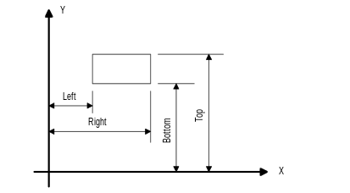
gpRect2d
gpRect2d();
Default constructor. Sets the left, bottom, right, and top edges to zero.
gpRect2d
gpRect2d(Float64 left,
Float64 bottom,
Float64 right,
Float64 top);
Creates a rectangle with the given dimensions.
gpRect2d
gpRect2d(const gpPoint2d& bottomLeft,
const gpPoint2d& topRight);
Creates a rectangle with the give bottom left and top right corners.
gpRect2d
gpRect2d(const gpPoint2d& bottomLeft,
const gpSize2d& size);
Creates a rectangle with the given bottom left corner and give size.
operator =
gpRect2d& operator= (const gpRect2d& rOther)
Assigns the dimensions of rOther to this rectangle. Returns a reference to this.
Area
Float64 Area() const;
Returns the area of the rectangle.
IsNormalized
bool IsNormalized() const;
Returns true if left >= right or bottom >= top, otherwise returns false.
IsNull
bool IsNull() const;
Returns true if left, bottom, right, and top are all zero.
Set
void Set(Float64 left, Float64 bottom, Float64 right, Float64 top);
Repositions and resizes this rectangle to the given values.
Set
void Set(const gpPoint2d& bottomLeft, const gpPoint2d& topRight);
Repositions and resizes this rectangle using the given corner points.
SetNull
void SetNull();
Sets left, bottom, right, and top to zero.
SetWH
void SetWH(Float64 left,Float64 bottom,Float64 width, Float64 height);
Repositions and resizes this rectangle given a bottom left corner and edge dimensions.
SetWH
void SetWH(const gpPoint2d& bottomLeft, const gpSize2d& size);
Repositions and resizes this rectangle given a bottom left corner and edge dimensions.
Left
Float64 Left() const;
Float64& Left();
Returns the location of the left edge of the rectangle.
Bottom
Float64 Bottom() const;
Float64& Bottom();
Returns the location of the bottom edge of the rectangle.
Right
Float64 Right() const;
Float64& Right();
Returns the location of the right edge of the rectangle.
Top
Float64 Top() const;
Float64& Top();
Returns the location of the top edge of the rectangle.
TopLeft
gpPoint2d TopLeft() const;
Returns the top left corner of the rectangle.
TopRight
gpPoint2d TopRight() const;
Returns the top right corner of the rectangle.
BottomLeft
gpPoint2d BottomLeft() const;
Returns the bottom left corner of the rectangle.
BottomRight
gpPoint2d BottomRight() const;
Returns the bottom right corner of the rectangle.
Center
gpPoint2d Center() const;
Returns the center point of the rectangle.
TopCenter
gpPoint2d TopCenter() const;
Returns the center point of the top edge of the rectangle.
BottomCenter
gpPoint2d BottomCenter() const;
Returns the center point of the bottom edge of the rectangle.
LeftCenter
gpPoint2d LeftCenter() const;
Returns the center point on the left edge of the rectangle
RightCenter
gpPoint2d RightCenter() const;
Returns the center point on the right edge of the rectangle.
Size
gpSize2d Size() const;
Return a gpSize2d object representing the width and height of the rectangle.
Contains
bool Contains(const gpPoint2d& point) const;
Returns true if the given point lies within this rectangle, otherwise it returns false. If point is on the left vertical or bottom horizontal borders of the rectangle, Contains also returns true, but if point is on the right vertical or top horizontal borders, Contains returns false.
Contains
bool Contains(const gpRect2d& rOther) const.
Returns true if the rOther rectangle lies on or within this rectangle, otherwise it returns false.
Touches
bool Touches(const gpRect2d& rOther) const;
Returns true if the rOther rectangle shares any interior points with this rectangle, otherwise it returns false.
Height
Float64 Height() const;
Returns the height of the rectangle computes as m_Top - m_Bottom.
Width
Float64 Width() const;
Returns the width of the rectangle, computed as m_Right - m_Left;
Inflate
gpRect2d& Inflate(Float64 dx, Float64 dy);
Inflates a rectangle by the given delta arguments. The bottom left corner of the returned rectangle is (left - dx, bottom - dy), while its top right corner is (right + dx, top + dy).
Inflate
gpRect2d& Inflate(const gpSize2d& size);
Inflates a rectangle by the given delta arguments. The bottom left corner of the returned rectangle is (left - size.dx, bottom - size.dy), while its top right corner is (right + size.dx, top + size.dy).
InflateBy
gpRect2d InflateBy(Float64 dx, Float64 dy) const;
Inflates a rectangle by the given delta arguments. The bottom left corner of the returned rectangle is (left - dx, bottom - dy), while its top right corner is (right + dx, top + dy). The calling rectangle is unchanged.
InflateBy
gpRect2d InflateBy(const gpSize2d& size) const;
Inflates a rectangle by the given delta arguments. The bottom left corner of the returned rectangle is (left - size.dx, bottom - size.dy), while its bottom right corner is (right + size.dx, top + size.dy). The calling rectangle is unchanged.
MoveTo
gpRect2d& MoveTo(Float64 left, Float64 bottom);
gpRect2d& MoveTo(const gpPoint2d& bottomLeft);
Move the lower left corner of the rectangle to a new location and maintain the current dimension.
MovedTo
gpRect2d MovedTo(Float64 left,Float64 bottom);
gpRect2d MovedTo(const gpPoint2d& bottomLeft);
Move the lower left point of the rectangle while maintaining the current dimension. The calling rectangle is unchanged.
Normalize
gpRect2d& Normalize();
Normalizes this rectangle by switching the left and right data member values if left > right, and switching the top and bottom data member values if top < bottom. Normalize returns the normalized rectangle. A valid but non-normal rectangle might have left > right or top < bottom or both. In such cases, many manipulations (such as determining width and height) become unnecessarily complicated. Normalizing a rectangle means interchanging the corner point values so that left < right and top > bottom. The physical properties of a rectangle are unchanged by this process.
Normalized
gpRect2d Normalized() const;
Returns a normalized rectangle with the bottom left corner at (Min(left, right), Min(top, bottom)) and the top right corner at (Max(left, right), Max(top, bottom)). The calling rectangle object is unchanged. A valid but non-normal rectangle might have left > right or top < bottom or both. In such cases, many manipulations (such as determining width and height) become unnecessarily complicated. Normalizing a rectangle means interchanging the corner point values so that left < right and top > bottom. The physical properties of a rectangle are unchanged by this process.
Offset
gpRect2d& Offset(Float64 dx, Float64 dy);
Changes this rectangle so its corners are offset by the given delta values. The revised rectangle has a bottom left corner at (left + dx, bottom + dy) and a top right corner at (right + dx, top+ dy). The revised rectangle is returned.
OffsetBy
gpRect2d OffetBy(Float64 dx, Float64 dy);
Returns a rectangle with the corners are offset by the given delta values. The rectangle has a bottom left corner at (left + dx, bottom + dy) and a right top corner at (right + dx, top + dy).
Union
gpRect2d& Union(const gpRect2d& rOther);
Changes the dimensions of this rectangle equal to the union of it and the other rectangle. The union is the smallest rectangle that contains both source rectangles. Note: Both of the rectangles must be normalized or this function will throw a sysXProgrammingError exception. You can call Normalize() to normalize the rectangles before calling this function.
UnionBy
gpRect2d UnionBy(const gpRect2d& rOther) const;
Makes a gpRect2d with dimensions equal to the union of it and the other rectangle. The union is the smallest rectangle that contains both source rectangles. Note: Both of the rectangles must be normalized or this function throw a sysXProgrammingError exception. You can call Normalize() to normalize the rectangles before calling this function.
Intersection
gpRect2d& Intersection(const gpRect2d& rOther);
Changes the dimensions equal to the intersection of the two rectangles. The intersection is the largest rectangle contained in both existing rectangles. Note: Both of the rectangles must be normalized or this function throw a sysXProgrammingError exception. You can call Normalize() to normalize the rectangles before calling this function.
IntersectionBy
gpRect2d IntersectionBy(const gpRect2d& rOther) const;
Makes a gpRect2d with dimensions equal to the intersection of the two rectangles. The intersection is the largest rectangle contained in both existing rectangles. Note: Both of the rectangles must be normalized or this function throw a sysXProgrammingError exception. You can call Normalize() to normalize the rectangles before calling this function.

Free Operators
operator ==
bool operator==(const gpRect2d& lhs, const gpRect2d& rhs);
Returns true if lhs is equal to rhs, otherwise returns false.
operator !=
bool operator!=(const gpRect2d& lhs, const gpRect2d& rhs);
Returns true if lhs is not equal to rhs, otherwise returns false.

gpLine2d
gpLine2d encapsulates the notion of a line with infinite length.

Public Interface - Member Functions
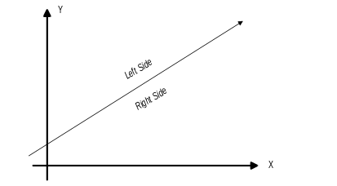
gpLine2d
gpLine2d();
Default constructor. Creates a line parallel to the x-axis at y = 0.
gpLine2d
gpLine2d(const gpPoint2d& p1,const gpPoint2d& p2);
Explicit constructor. Creates a line passing through points p1 and p2.
gpLine2d
gpLine2d(const gpLineSegment2d& ls);
Explicit constructor. Creates a line from line segment ls.
gpLine2d
gp2dLine(Float64 c, const gp2dVector& rn);
Explicit constructor. Creates a line from its implicit representation. Refer to Graphics Gems, Chapter 1 for details.
c - distance from closest point on origin to the origin.
rn - vector normal to the line. Left side of line is in positive rn.
gpLine2d
gp2dLine(const gp2dPoint& ru, const gp2dVector& rv);
Explicit constructor. Creates a line from its explicit representation. Refer to Graphics Gems, Chapter 1 for details.
ru - a point on the line.
rv - tangent vector to line. Left side of line is on left looking in positive rv direction.
gpLine2d
gpLine2d(const gpLine2d& rOther);
Copy constructor. Creates a copy of line rOther.
operator =
gpLine2d& operator = (const gpLine2d& rOther);
Assignment operator. Assigns to this line the attributes of rOther.
Contains
bool Contains(const gpPoint2d& point) const;
Returns true if point is contained in the locus of points that define this line, otherwise returns false.
GetSlope
Float64 GetSlope() const;
Returns the slope of the line. If the line is vertical and pointing upwards, returns std::numeric_limits<float>::infinity(). If the line is vertical and pointing downwards, returns negative std::numeric_limits<float>::infinity().
SetImplicit
void SetImplicit(Float64 c, const gp2dVector& rn);
Set implicit form of line.
GetImplicit
void GetImplicit(Float64* pc, gp2dVector* rn) const;
Get implicit form of line.
SetExplicit
void SetExplicit(const gp2dPoint& ru, const gp2dVector& rv);
Set explicit form of line.
GetExplicit
void GetExplicit(gp2dPoint* pu, gp2dVector* pv) const;
Get explicit form of line.
SetPoints
void SetPoints(const gp2dPoint& p1,const gp2dPoint& p2);
Sets a line passing through points p1 and p2. Has the same behavior as the default constructor if the points are identical. These points are not retrievable.
Offset
gpLine2d& Offset(Float64 dx,Float64 dy);
gpLine2d& Offset(const gpSize2d& size);
Offsets this line by the given delta arguments. This line is changed by translating its control points by the given distance. Returns a reference to this line.
OffsetBy
gpLine2d OffsetBy(Float64 dx, Float64 dy) const;
gpLine2d OffsetBy(const gpSize2d& size) const;
Returns a line which is offset to this line by the given displacement arguments. This line is not changed.
PointOnLineNearest
gpPoint2d PointOnLineNearest(const gpPoint2d& point) const;
Returns a point on the line which is nearest to the given point.
DistanceToPoint
Float64 DistanceToPoint(const gpPoint2d& point) const;
Returns the distance from the line to a given point. If the point is on the left side of the line, it returns a positive value. If the point is on the right side of the line it returna a negative value.
Rotate
gpLine2d& Rotate(const gpPoint2d& centerPoint, Float64 angle);
Rotates this line about the given center point by the given angle (in radians). This line is changed. Returns a reference to this line.
RotateBy
gpLine2d RotateBy(const gpPoint2d& centerPoint, Float64 angle) const;
Returns a line equal to this line rotated about the given center point by the given angle (in radians). This line is not changed.
Parallel
gpLine2d Parallel(Float64 offset, gpLine2d::Side side) const;
Returns a line that is parallel to this line and offset from this line by the specified amount. The offset is measured perpendicular to this line. An negative offset reverses the effect of the side argument.
Parallel
gpLine2d Parallel(const gpPoint2d& point) const;
Returns a line that is parallel to this line and passes through point.
Normal
gpLine2d Normal(const gpPoint2d& point) const;
Returns a line that is normal to this line and passes through point.

Public Interface - Enumerations
Side
enum { Left, Right } Side;
The side of a line can be best defined by an illustration. Imagine you are standing at the point P1 and looking toward P2: Left is the left size, Right is the Right side.

gpLineSegment2d
gpLineSegment2d encapsulates the notion of a line with finite length.
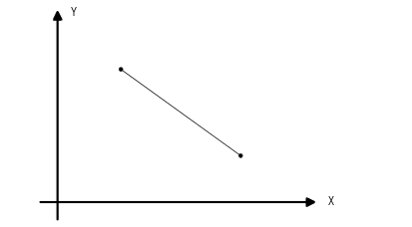

Public Interface - Member Functions
gpLineSegment2d
gpLineSegment2d();
Default constructor. Creates a zero length line segment at (0,0).
gpLineSegment2d
gpLineSegment2d(const gpPoint2d& start, const gpPoint2d& end);
Explicit constructor. Creates a line segment from start to end.
gpLineSegment2d
gpLineSegment2d(const gpPoint2d& start, const gpSize2d& relEnd);
Explicit constructor. Creates a line segment that starts at start and ends at (start.X()+relEnd.Dx(),start.Y()+relEnd.Dy()).
gpLineSegment2d
gpLineSegment2d(const gpLineSegment2d& rOther)
Copy constructor. Creates a line segment that is identical to rOther.
operator =
gpLineSegment2d& operator=(const gpLineSegment2d& rOther);
Assignment operator. Assigns the start and end points of rOther to this line segment. Returns a reference to this line segment.
Contains
bool Contains(const gpPoint2d& point) const;
Returns true if point is contained between the end points of this line segment, otherwise returns false.
Length
Float64 Length() const;
Returns the length of the line segment.
SetStartPoint
void SetStartPoint (const gpPoint2d&);
Sets the start point of the line segment.
GetStartPoint
gpPoint2d GetStartPoint() const;
Returns the start point of the line segment.
SetEndPoint
void SetEndPoint(const gpPoint2d&);
Sets the end point of the line segment.
GetEndPoint
gpPoint2d GetEndPoint() const;
Returns the end point of the line segment.
Offset
gpLineSegment2d& Offset(Float64 dx,Float64 dy);
gpLineSegment2d& Offset(const gpSize2d& size);
Offsets this line segment by the given delta arguments. This line is changed by translating its control points by the given distance. Returns a reference to this line segment.
OffsetBy
gpLineSegment2d OffsetBy(Float64 dx, Float64 dy) const;
gpLineSegment2d OffsetBy(const gpSize2d& size) const;
Returns a segment line which is offset to this line segment by the given displacement arguments. This is not changed.
Rotate
gpLineSegment2d& Rotate(const gpPoint2d& centerPoint, Float64 angle);
Rotates this line segment about the given center point by the given angle (in radians). This is changed. Returns a reference to this line segment.
RotateBy
gpLineSegment2d RotateBy(const gpPoint2d& centerPoint, Float64 angle) const;
Returns a line segment equal to this line segment rotated about the given center point by the given angle (in radians). This is not changed.

Implementation Notes
Contains could be implemented by computing the distance between the start point of the line segment and the given point, and the distance between the end point of the line segment and the given point. If the sum of these distance doesn’t equal the length of the line segment, then the point isn’t contained.

gpGeomOp2d
Utility class for geometric operations on 2d geometric primitives. This class encapsulates operations that do not fit nicely into either class that they operate on.

Public Interface - Member Functions
Intersect
static int Intersect(gpPoint2d& p,
const gpLineSegment2d& l1,
const gpLineSegment2d& l2);
static int Intersect(gpPoint2d& p,
const gpLine2d& l1,
const gpLine2d& l2);
static int Intersect(gpPoint2d& p,
const gpLineSegment2d& l1,
const gpLine2d& l2);
static int Intersect(gpPoint2d& p,
const gpLine2d& l1,
const gpLineSegment2d& l2);
Finds the intersection between line (segment) l1 and l2 and stores the result in p. Returns the number of intersections found. Returns 0 if the lines are parallel or do not intersect, the contents of p are undefined. Returns 1 if an intersect is found, p contains the intersection point. Returns -1 if the lines are collinear and overlapping, p contains the coordinates of the first overlapping point..
IsParallel
static bool IsParallel(const gpLineSegment2d& l1,
const gpLineSegment2d& l2);
static bool IsParallel(const gpLine2d& l1,
const gpLine2d& l2);
static bool IsParallel(const gpLineSegment2d& l1,
const gpLine2d& l2);
static bool IsParallel(const gpLine2d& l1,
const gpLineSegment2d& l2);
Returns true if l1 and l2 are parallel, otherwise returns false.

Implementation Notes
The constructors of this class should be declared private and not implemented. This is a utility class and there should never be an instance of it.

gpPolygon2d
gpPolygon2d encapsulates the notion of straight-sided polygon. The polygon is described by its vertex points.

Public Interface - Member Functions
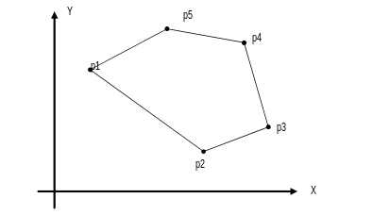
gpPolygon2d
gpPolygon2d();
Default constructor. Creates a polygon with no vertex points.
gpPolygon2d
gpPolygon2d(const gpPolygon2d& rOther)
Copy constructor. Creates a polygon that is identical to rOther.
operator =
gpPolygon2d& operator=(const gpPolygon2d& rOther);
Assignment operator. Assigns the vertex points of rOther to this polygon. Returns a reference to this polygon.
AddPoint
Uint32 AddPoint(const gpPoint2d& p);
Adds a point to the polygon. Returns a key that can be used to lookup the point in later operations.
RemovePoint
bool RemovePoint(Uint32 key)
Removes a point from the polygon. If the point could not be found, this method does nothing. Returns true if the point was successfully removed, otherwise false.
GetPoint
const gpPoint2d* GetPoint(Uint32 key) const;
Returns a pointer to the point identified by key. If the point could not be found, returns -0.
ReplacePoint
bool ReplacePoint(Uint32 key,const gpPoint2d& p);
Replaces the point identified by key with point p. Returns true on success, otherwise return false.
GetNumPoints
Uint32 GetNumPoints() const;
Returns the number of vertex points on the polygon.
Clear
void Clear();
Removes all vertex points from the polygon.
Contains
bool Contains(const gpPoint2d& point) const;
Returns true if point is contained within this polygon, otherwise returns false. Points on the polygon boundary are considered contained. Postpone implementation until needed.
Perimeter
Float64 Perimeter() const;
Returns the perimeter of the polygon.
GetProperties
void GetProperties(Float64* Area,Float64* Ixx,Float64* Iyy,
Float64* Ixy, gpPoint2d* centroid) const;
Returns the centroidal properties of the polygon. Properties for counter-clockwise defined polygons are positive, for clockwise-defined polygons, they are negative.
BoundingBox
gpRect2d GetBoundingBox() const;
Returns a gpRect2d which defines the bounding box of the polygon.
Offset
gpPolygon2d& Offset(Float64 dx,Float64 dy);
gpPolygon2d& Offset(const gpSize2d& size);
Offsets this polygon by the given delta arguments. This polygon is changed by translating its control points by the given distance. Returns a reference to this polygon.
Rotate
gpPolygon2d& Rotate(const gpPoint2d& centerPoint, Float64 angle);
Rotates this polygon about the given center point by the given angle (in radians). This is changed. Returns a reference to this polygon.
CreateClippedPolygon
gpPolygon2d* CreateClippedPolygon(const gpLine2d& line,
gpLine2d::Side side
) const = 0;
Clips this polygon against line. Returns the portion of the polygon on the side of the line defined by side. This is a factory method. You are responsible for freeing the memory allocated by this method. If the polygon lies entirely on the clipping side of the line 0 is returned.
CreateClippedPolygon
gpPolygon2d* CreateClippedPolygon(const gpRect2d& r,
gpPolygon2d::ClipRegion region
) const = 0;
Clips this polygon against rectangle r. Returns the portion that is in or out of the rectangle as specified by region. This is a factory method. You are responsible for freeing memory allocated by this method. This method returns 0 if, the polygon lies entirely within the clipping rectangle and region is set to clip out, or the polygon and the rectangle do not intersect and region is to clip in.
GetFurthestDistance
virtual Float64 GetFurthestDistance(const gpLine2d& line,
gpLine2d::Side side) const = 0;
Returns the distance to a line that is parallel to line, on specified side of line, that passes through the furthest point on the shape from line.

Public Interface - Enumerations
ClipRegion
enum { In, Out } ClipRegion

Implementation Notes
Polygons defined counter-clockwise have positive areas and moments of inertia while polygons defined clockwise have negative properties. Users of this class may want to control solidness and hollowness at their level. To make a negative polygon solid, simply multiply all properties obtained from the GetProperties() function by -1.

gpPolyPointIter2d
This is a helper class used to iterate through the points in a gpPolygon2d object. gpPolyPointIter2d does an insertion order traversal of the points in the gpPolygon it is associated with.

Public Interface - Member Functions
The gpPolyPointIter2d class will implement the standard iterator methods Begin(), End(), Next(),and operator void *(). The standard GetCurrent() iterator method for this class is described below.
gpPolyPointIter2d
gpPolyPointIter2d();
Default constructor. An iterator created with this constructor is not associated with a polygon. Attempting to iterate with this iterator is safe, though it doesn’t do anything. Calls to CurrentPoint() will return a null pointer. To associate this iterator with a polygon use SetPolygon().
gpPolyPointIter2d
gpPolyPointIter2d(gpPolygon2d* pPolygon);
Explicit constructor. Creates an iterator that iterates through the points in pPolygon.
operator=
gpPolyPointIter2d& operator=(const gpPolyPointIter& rOther);
Assignment operator.
SetPolygon
void SetPolygon(gpPolygon2d* pPolygon);
Sets the polygon for iteration. Sets the iterator position to Begin().
CurrentPoint
gpPoint2d* CurrentPoint();
Returns a pointer to the constant current point or a null pointer if nothing exists. This pointer may be used to modify the point if desired.
CurrentKey
const Uint32* CurrentKey() const;
Returns a pointer to the current key. If there is not a current element, returns 0.

3D Geometric Primitives
The 3 Dimensional Geometric Primitives Package provides point, cube, volume, line, line segment, and plane geometric constructs. The classes in this package are typically used as helpers when dealing with geometrical constructs. The primitives in this package reflect geometric constructs in real coordinate space.

